CSEE 5113 – Network Routing

Assignment – 1

By:

Adarsh Mergoju

16246333

UMKC

The aim of this assignment was to configure the IP addresses of the routers and end systems connected to them. Then determine the hop count when the traceroute is performed one end system to another.

1. The topology shown below is done on the Cisco Packet Tracer. The IP addresses have been assigned as shown.

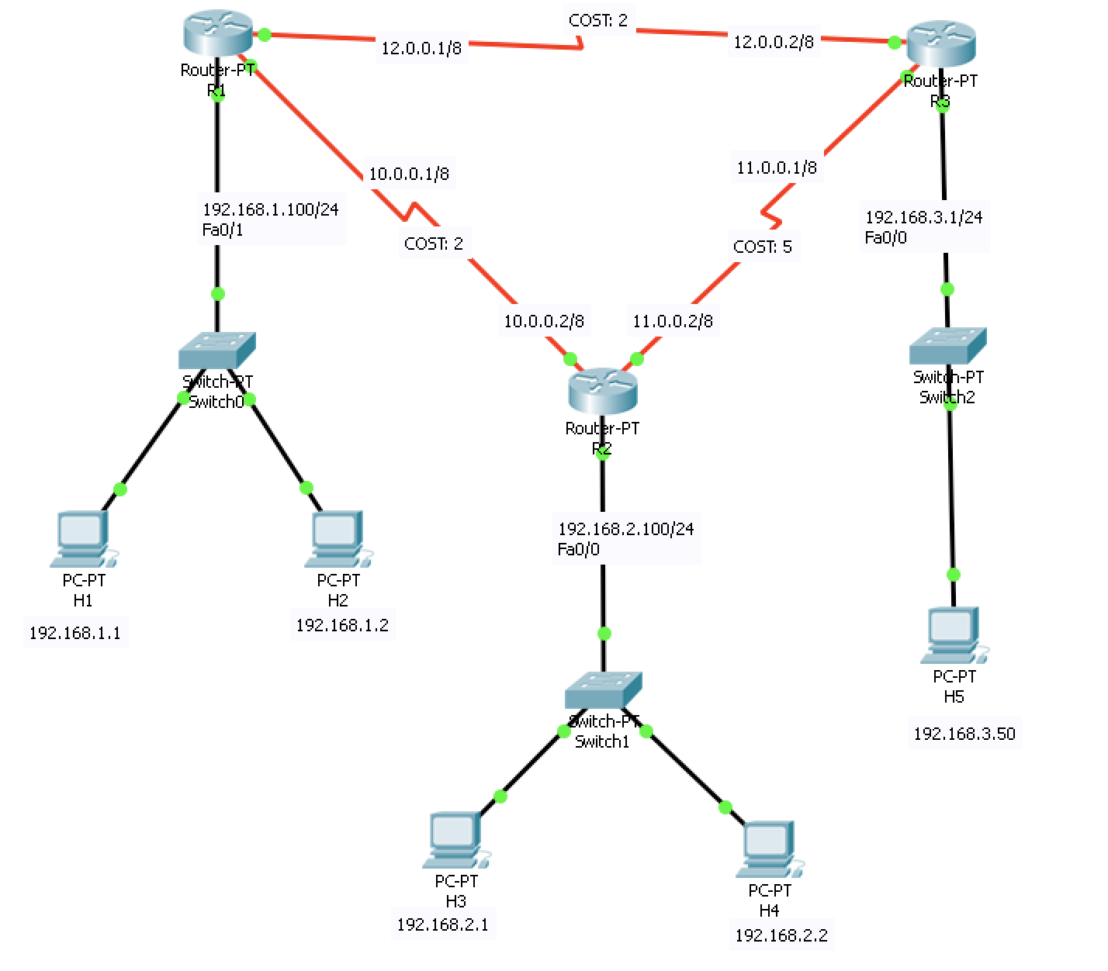

Figure : Network Topology

1. OSPF configuration

At Router 1

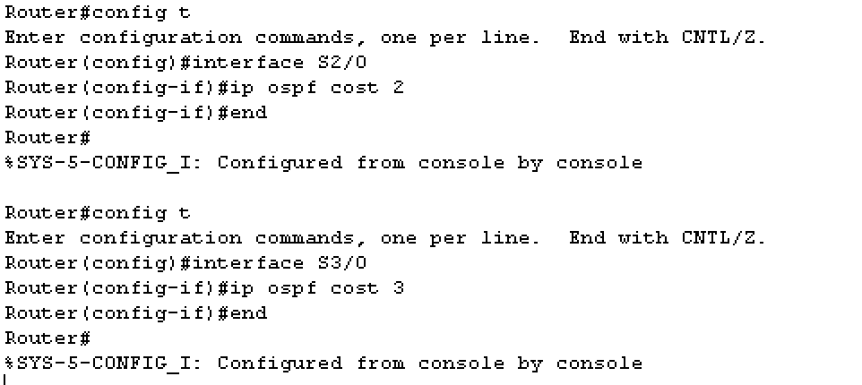

Figure : OSPF Configuration at router 1

At Router 2

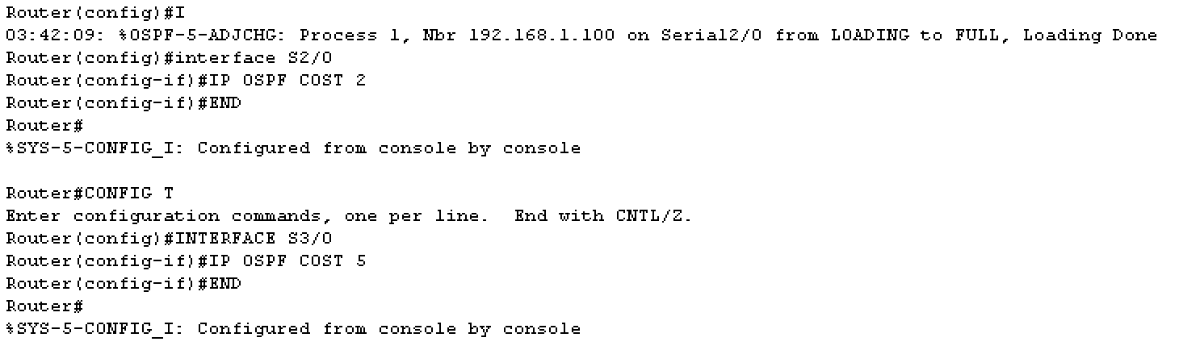

Figure : OSPF configuration at router 2

At Router 3

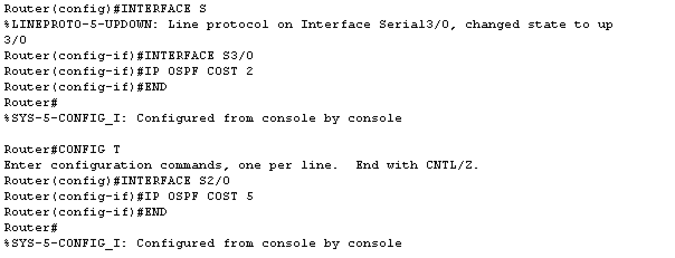

Figure : OSPF configuration at Router 3

iii) Trace Route from H1 to H3:

H1: **192.168.1.1** H3: **192.168.2.1**

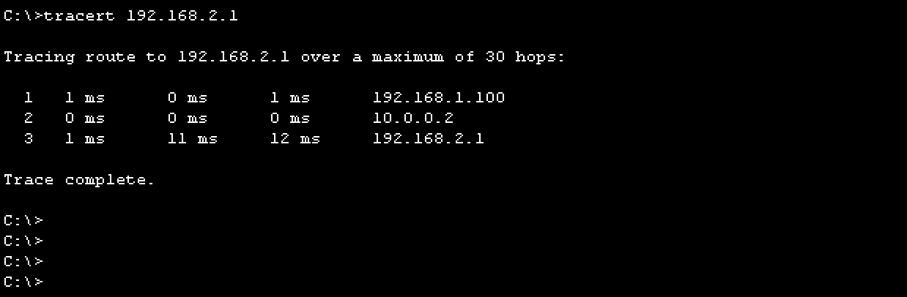

Figure : trace-route from h1 to h5

iv) Trace Route from H1 to H5:

H1: **192.168.1.1** H5: **192.168.3.50**

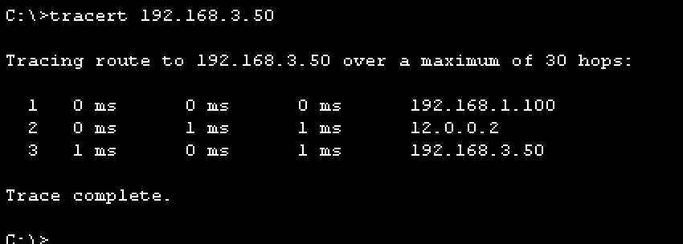

Figure : trace-route from h1 to h5

v) We can observe that, the route from H1 to both H3 and H5 takes the shortest path with the least cost. The main difference is the interface chosen for each destination.

For H1-H3:

* The interface with 12.0.0.0 network ID is chosen.
* The time taken for the final hop is 12ms.

For H1-H5:

* The interface with 10.0.0. network ID is chosen.
* The time taken for the final hop is 1ms.

vi) The IP interfaces for each router are as follows:

**Router 1**

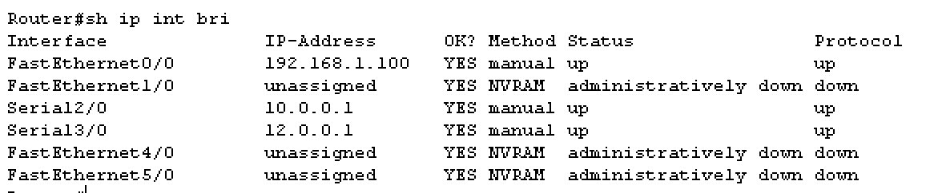

Figure : Interfaces at Router 1

**Router 2**

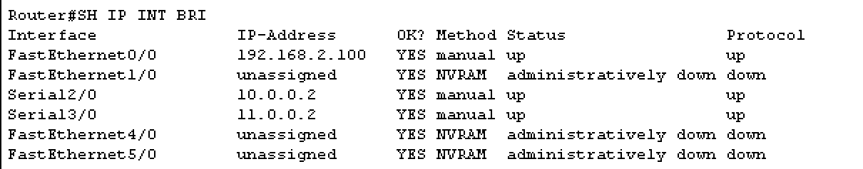

Figure : Interfaces at Router 2

**Router 3**

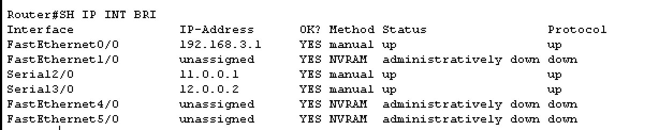

Figure : Interfaces at Router 3

vii) The IP route for each router are as follows:

**Router 1**

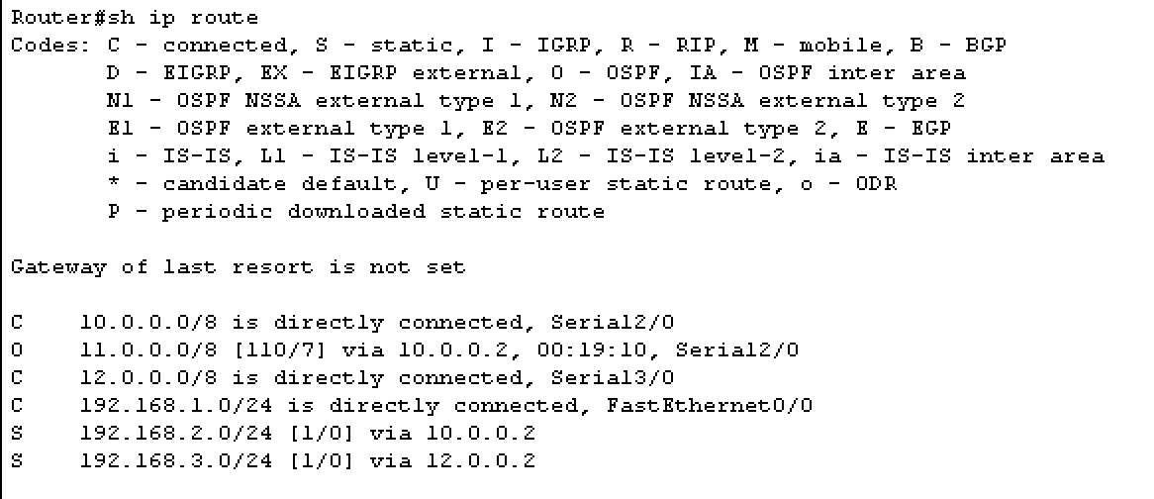

Figure : Routing Table at Router 1

**Router 2**

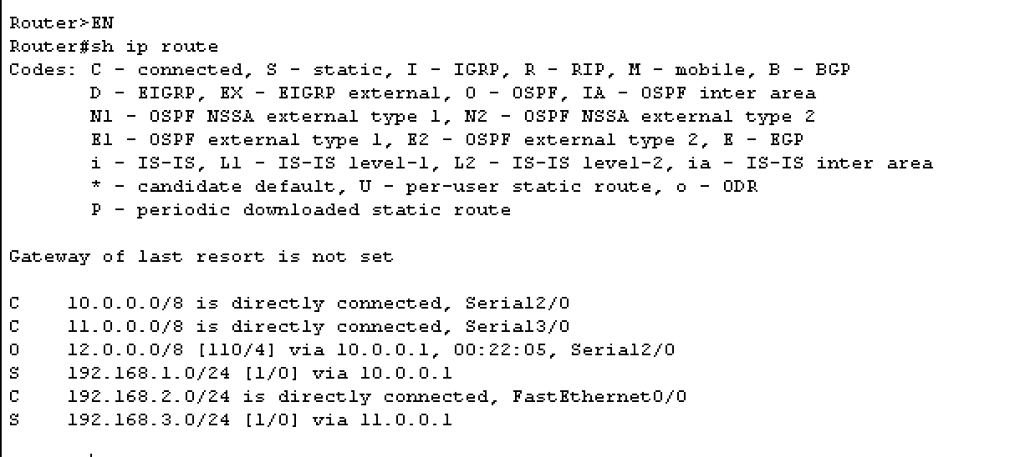

Figure : Routing Table at Router 2

**Router 3:**

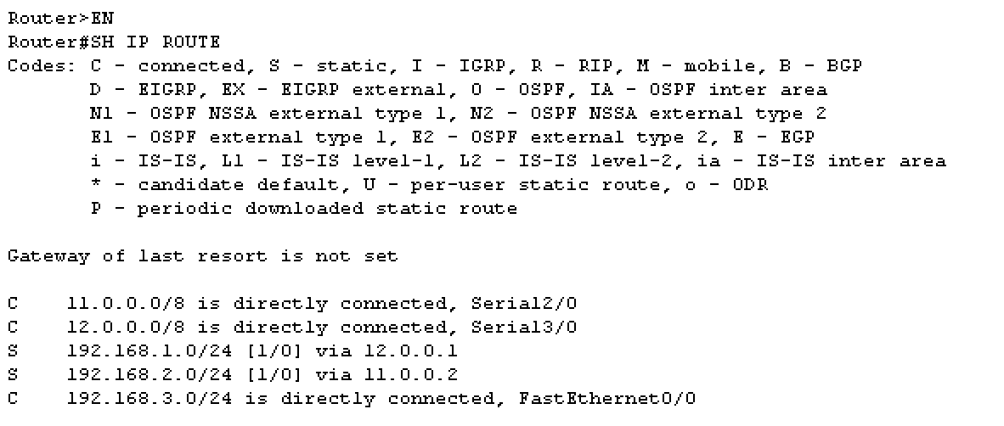

Figure : Routing Table at Router 3

When the link between R1 and R3 fails, let’s assume the link to be removed.

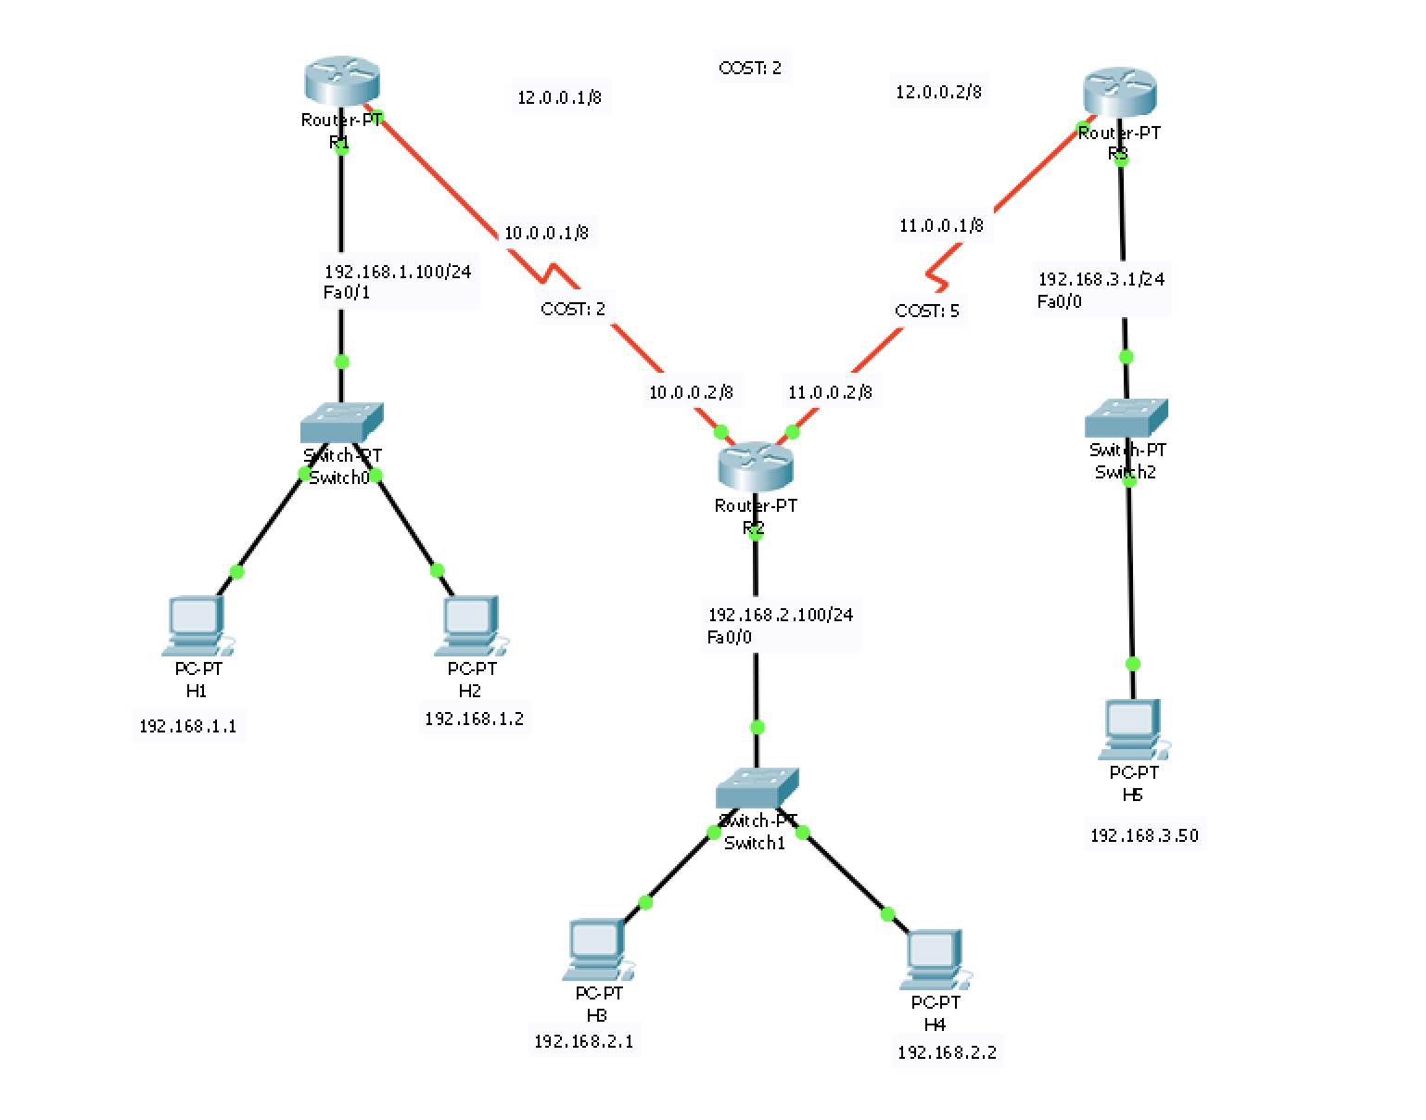

Figure : Link between R1 and R3 removed.

The changes in the IP route can be seen as such.

At Router 1:

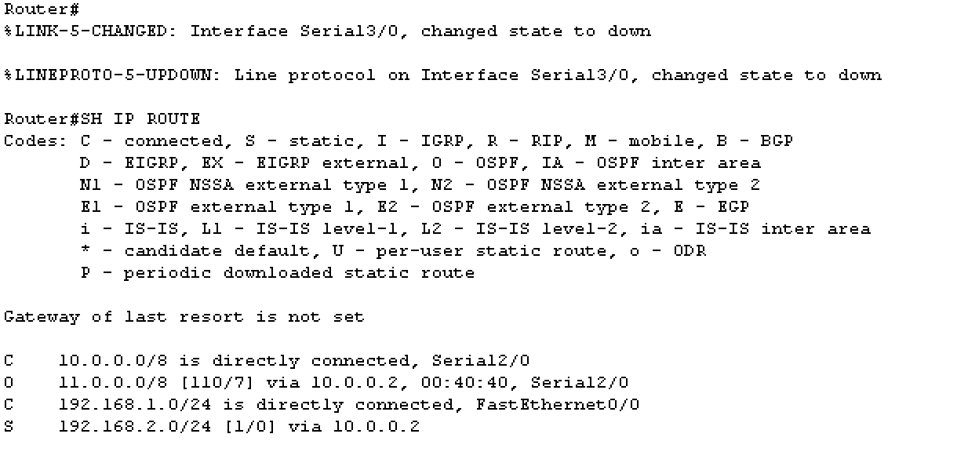

Figure : New Routing Table at R1

At Router 3:

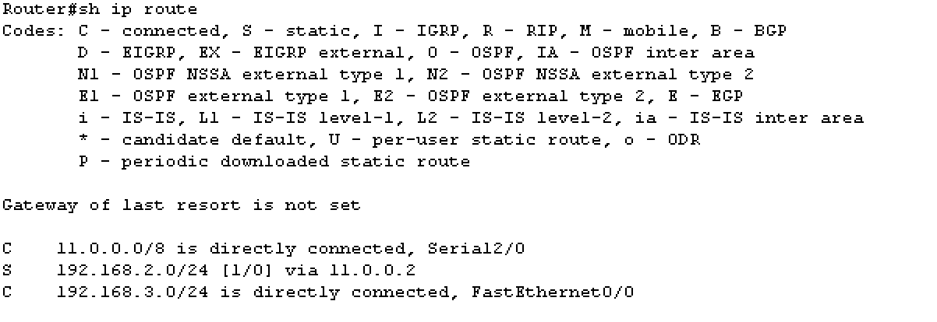

Figure : New Routing Table at R3

The link 12.0.0.0/8 from the previous figures is gone from the routing tables.